HOLY WEEK – GOOD FRIDAY

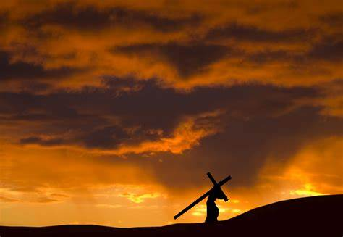

“The Way of the Cross,
Crucifixion
and Death”

Biblical Readings:
- Mt 27: 26-47
- Lk 23: 33-43
- Jn 19: 25-42

1. A Passion Day of Jesus according to St. Mark:

  - 6: 00am: As soon as morning came ... (Mk 15: 1)
  - 9: 00am: It was 9 o’clock in the morning ... (Mk 15: 25)
  - 12: 00pm: At noon darkness came ... (Mk 15: 33)
  - 3: 00pm: And at three o’clock ... (Mk 15: 34)
  - 6: 00pm: When it was already evening ... (Mk 15: 42)

2. The Lord Jesus’ Passion Week according to St. Mark:

  - Monday: Jesus entered Jerusalem (Mk 11: 11)
  - Tuesday: The next day (Mk 11: 12)
  - Wednesday: Early in the morning (Mk 11: 20)
  - Thursday: The Passion and the Feast of Unleavened Bread in two days’ time (Mk 14: 1)
  - Friday: On the First Day of the Unleavened Bread (Mk 14: 12)
  - Saturday: The day before Sabbath (Mk 15: 42)
  - Sunday: Very early... on the First Day of the Week (Mk 16: 2)

In imagination, I placed myself in the court-yard near the Praetorium. I heard people shouting, accusing, laughing and applauding loudly every time the soldiers whip Jesus. It was as if they are throwing their sins at Jesus. I wanted to stop them doing that, but I was afraid. I was afraid of the crowd and the soldiers.
We know the whipping was so severe that it tore the flesh from his body. The beating so horrific that his face was torn and his beard ripped from his face.

After whipping and torturing Jesus, the soldiers then formed a crown out of thorns and put it on Jesus’ head and mocked him. The crown of thorns cut deeply into his scalp. Finally, they made a cross for him to carry to Calvary in order to be crucified.
In imagination, I watch Jesus had to carry a heavy cross and he fell three times. I follow him every step and share with him his pain. Every time he fell, he was beaten very hard. As he could no longer carry the cross, they picked one of the passers-by and forced him to carry the cross for Jesus to the Calvary. His name was Simon.

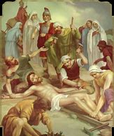
On the top of the Skull Hill, they crucified him.

A hammer drove large nails through the wrists, the feet overlapped and an even larger nail hammered through the arches.
I stood behind the rock on his right hand-side and looked at him. His eyes were closed. He seemed to be in great pain. His body shook every now and then. At the wounds of the nailing, the blood exuded and dropped on the ground. From time to time, he was forced to support himself on the single nail that impaled his feet to the cross. He could not support himself with his legs because of the pain, so he was forced to alternate between arching his back, then using his legs just to continue to breathe. I could feel his struggle, his pain, his suffering and his courage.

Over 3 hours he had to endure this kind of suffering!

Suddenly, in my mind’s eye, he lifted up his head, opened his eyes and looked towards me in the most tenderly way I’ve never seen.

  - He looked at me as if he wanted to thank me for following him to this end of his life.
  - He looked at me as if he wanted to say to me that he knew I followed him and he would never forget me.
  - He looked at me as if he wanted me to continue to be with him and to be close to him.
  - He looked at me as if he wanted to say to me that though he dies he is still alive...
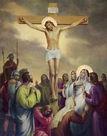
After that, bowing his head, Jesus handed over his spirit (Jn 19: 30).

Jesus had to endure this experience, so that the whole of humanity could have free access to God and human sins could be “washed” away!

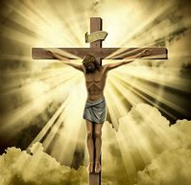

Crucifixion and Death
